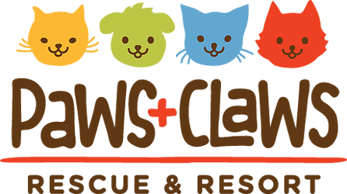

New Client Form & Boarding Agreement

Your information:

Name:___________________________________ Spouse/Co-owner:_____________________________
Phone 1:_________________________________ Phone 2:_____________________________________
Email:________________________________________________________________________________
Address:______________________________________________________________________________
City, State, Zip:_________________________________________________________________________
Emergency Contact Name & Number: ______________________________________________________
Relationship to Owner: ____________________________________________________________
Your Pet’s Primary Veterinary Clinic: _______________________________________________________
Your Veterinarian’s Name:_________________________________________________________
Clinic Phone Number:_____________________________________________________________
How did you hear about us?______________________________________________________________
Additional Services Available:
- Feeding our food - $1.50 per meal

Photo Release Consent
I grant Paws+Claws Rescue & Resort the permission to take photographs of myself and/or my pet(s) to copyright, use, and/or publish in print or electronically. Yes No

Pet Information – Please complete one for each pet.
Name:_______________________________ Birthdate/Age:____________________
Breed, Color, Markings: _________________________________________________
Gender: Male Female Spayed/Neutered? Yes No
Feeding Schedule:______________________________________________________
Feeding Instructions (i.e. amount, feed separately from other pet(s), free feed, etc: ______________________________________________________________________
Medical & Behavioral History – Does your pet…
Receive any medications or supplements?
_____________________________________________________________________
Have any allergies?: Yes No
_____________________________________________________________________
Have any behavior concerns? (i.e. chewing, jumping, climbing fences, etc):
_____________________________________________________________________
Have any additional medical concerns? (i.e. epilepsy, temporary injury, etc):
_____________________________________________________________________
May your pet(s) be allowed outside without direct supervision? Yes No
Any outdoor restrictions due to health?____________________________________________
Additional Concerns:
_______________________________________________________________________________
_______________________________________________________________________________

Things to Know
When preparing food for your pet(s):
- If you only feed your pet(s) dry food, it’s best to have each meal individually measured
into small Ziplock® bags. Otherwise, all food must be supplied along with either the
measuring cup you use, a similar cup or exact measurement for each meal according to
an everyday cooking/baking kitchen measuring cup.

- If what you feed your pet(s) is more involved than dry food or directly from a can, please
prepare and supply individual meals in small Ziplock® bags or containers. If your trip will
be long, we can freeze what doesn’t get used immediately and thaw a serving for each
meal.

- Please label all food and containers with your pet’s name!

- Be sure to always send at least three (3) extra meals in case your travels are interrupted
or extended, or to have in case of emergency.
Other things to bring:
- DON’T FORGET TO BRING MEDICATIONS
- Bedding, blankets, sweatshirts, pillows, etc., that are familiar to them; however, understand dogs sometime destroy belongings when they are stressed. Do not bring your irreplaceable, cherished items. (Note: We do provide bedding for all pets, unless we are directed otherwise.)
- Chew toys, bones, Kongs®, tennis balls, etc.
Please Note:
DOGS MUST BE ON A LEASH, AND CATS IN A CARRIER COMING IN AND OUT OF THE BUILDING.

